Grilled Shrimp Skewers with Pineapple
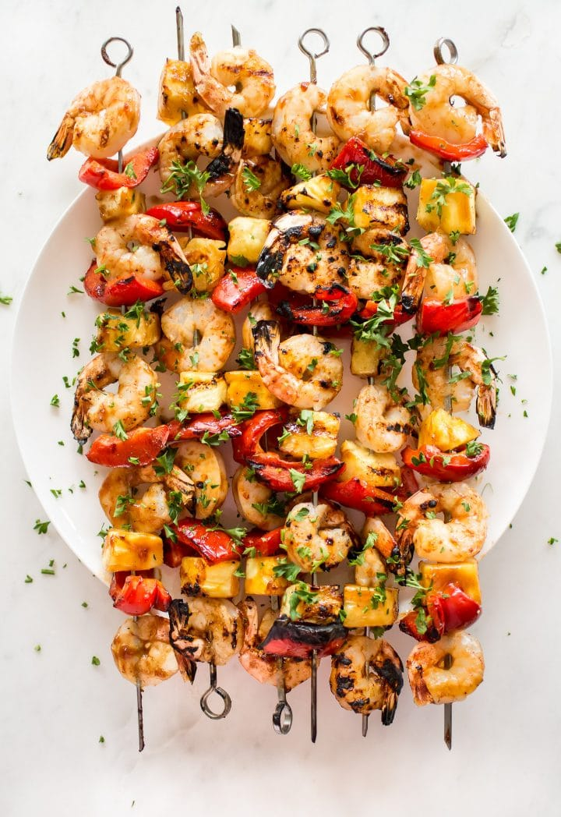
DESCRIPTION:
A simple tasty recipe for Grilled Shrimp Skewers fresh pineapple in a flavorful, chipotle marinade bursting with South American flavors. Serve with Jicama Slaw!

INGREDIENTS:
1 pound large raw, peeled and deveined shrimp ( 21-15 or 16-20 size)
1 pound pineapple chunks- cut to same thickness as shrimp ( about 3/4 inch thick)
Marinade:
3 tablespoons olive oil
1 lime – 1/8 cup lime juice and it’s zest
1 orange- 1/4 cup orange juice
1 tablespoon honey or maple
3 cloves rough chopped garlic
1 teaspoon salt
1/2 teaspoon cumin
1/2 teaspoon coriander
1/2 teaspoon chili powder
1/2 teaspoon chipotle powder, more for spicy ( or 1/2 of a canned chipotle chili in adobo sauce)
Garnish – limes, cilantro, Jicama Mango Slaw
Cook Mode Prevent your screen from going dark

INSTRUCTIONS:
Soak skewers if using wood.
Place shrimp in a bowl or ziplock bag.
Blend marinade ingredients together in a blender until smooth.
Pour marinade over shrimp and marinate 20-30 minutes. Prep pineapple.
Pre-heat grill to medium.
Drain the marinade from the bag or bowl into a small saucepan.
Skewer shrimp and pineapple, alternating on skewers ( Skewer pineapple the flat way so shrimp and pineapple are about the same wide, and both lay flat on the grill. That way you will have good grill marks on both. This should make 10-12 x 10-inch skewers.
Give the marinade a quick simmer, until it thickens and darkens a bit. Turn heat off.
Grease the grill well.
Lay the skewers down, grilling each side about 3 minutes, or until good grill marks develop, and shrimp is cooked, but not overcooked.
Place on a serving platter. Drizzle with reduced marinade or lime.
Serve immediately.

NUTRITION:
Calories: 378

